Downloading and Installing UCINET:

1. From <https://sites.google.com/site/ucinetsoftware/home> click “Download” on the left side of the page and choose Ucinetsetup.exe. This is the full-version. While it is paid software (currently $40 for students and $150 for faculty), there is a 60-day fully functional trial period. Do not start with the 64-bit version as it is slower to receive updates and has stability issues. Mac users can follow the direction [here](https://docs.google.com/document/d/1JDAWJTMiFzPCY74IOmlBR4-b_PpImihOgrSjS474C1Y/edit) and download Wine from <http://darwine-winebottler.en.softonic.com/mac> if they don’t already have it installed on their system.
2. When you run the installer, it works best to right-click and select “Run as administrator”. Follow the directions to complete the installation. This also installs Netdraw, Pajek, and Mage, three standalone visualization programs that are integrated into the UCINET interface.
3. For the demo, you will also need the mesaadj.csv and mesaatt.csv files either produced in R with the [MesaExport](https://github.com/ndporter/snademo/blob/master/MesaExport.R) script or downloaded directly from the github [repository](https://github.com/ndporter/snademo).
4. You may also want to take a look at the free online tutorial textbook or Borgatti et al’s new book *Analyzing Social Networks* if you’re planning on using UCINET. Information on both is in the main UCINET screen.

Using UCINET:

1. First opening UCINET does not provide an intuitive approach, although it is fairly simple to operate once you understand the logic. The base screen looks like:  
   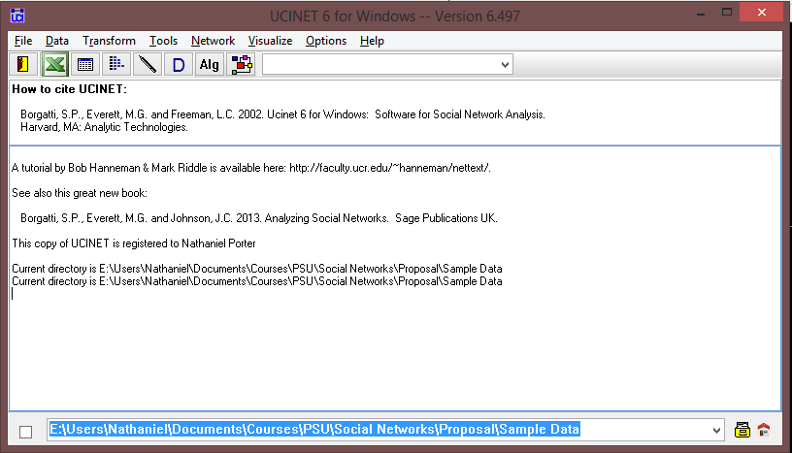
2. Before opening a datafile, it is worth changing the default directory, as nearly every command requires the selection of a data file and it streamlines matters if data are in a common directory. To do so, simply click the address bar at the bottom of the UCINET window and type the directory address *or* click the file drawer icon just to the right and navigate there using the interactive menu.
3. To import the data, you need to convert it from its existing format to a UCINET dataset. The most direct means of doing this is the menu command “Data – Import text file – raw matrix – raw matrix text file reader”. It will display the menu below. Make sure to select the mesaadj.csv file and check that you have selected that it has both column and row labels.  
   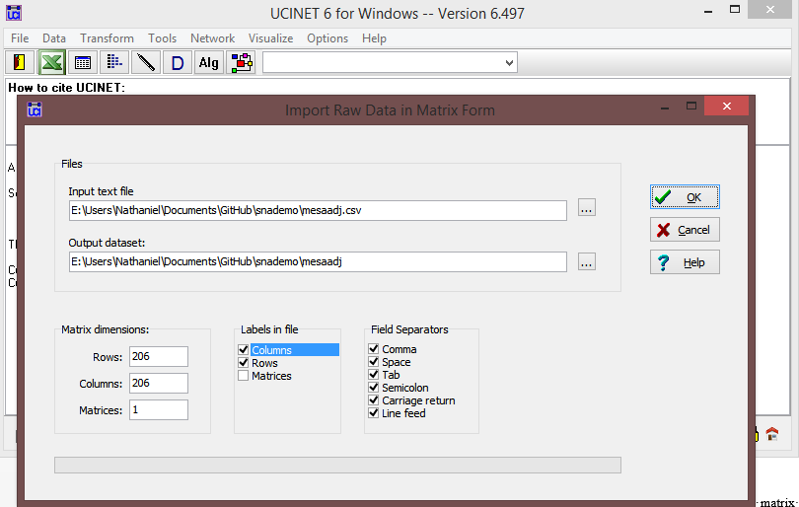  
   If you receive an “access violation” error message when clicking ok, you will need to use another program (probably Excel) to convert the file to an Excel spreadsheet before going on. To do so, open the file in Excel and “Save as – Excel Spreadsheet”. Once that is done, click the green Excel logo in the toolbar to open UCINET’s adaptation of Excel. Using the menu (not the toolbar), select “Open – Open Excel file” and choose your adjacency matrix. Make sure it looks right, then “Save- Save active sheet as UCINET dataset” and name you new dataset. Now you are ready to run some analyses.
4. Unlike other network software, UCINET does not store a dataset in memory unless it is currently being analyzed or visualized. Thus, you will have to select your file each time you ask for new measure. It also produces large quantities of both matrices and log files. For now, click “Network- Centrality and Power – Multiple Measures”. Enter your input matrix file (UCINET will automatically name the files it produces) and uncheck all of the measures except degree and betweenness. The dialog should resemble this:  
   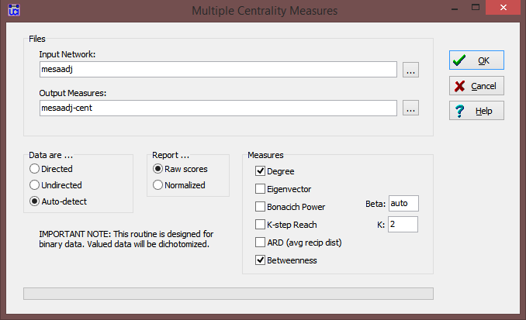

UCINET has just produced two different (albeit similar) outputs: a UCINET data file with a column for each measure you estimated (i.e. an attribute file for network attributes) and a text log file with a summary which you can close or save. Do notice that if you keep the same file and rerun the dialog with different measures or options, it will overwrite your prior output unless you change the output file name. Your new file can be used as attribute data or as input for other procedures.

1. In order to get the friend characteristic measures, first make sure you have converted the mesaatt.csv file to UCINET format following the procedure in step 3. Select “Networks – Ego Networks – EgoNet Composition – Continuous Alter Attribute” from the menus. The dialog should look like this:  
   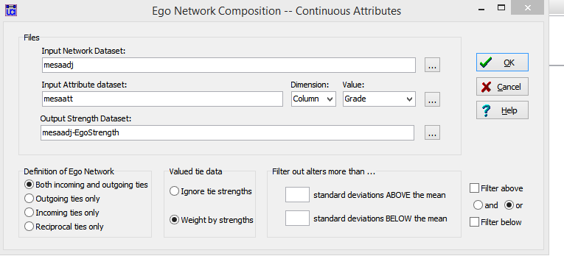

Choose your network and attribute datasets, and choose grade for the value to analyze for now. If your ties were directed or valued (i.e. how close are you to friend y), the options at the bottom would be important, but leave them alone for now and click ok. Your log shows that the first three cases had very different friendship patterns by grade:  
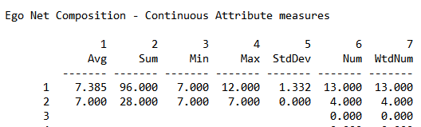  
Case “1” had thirteen friends ranging from grade 7-12 but primarily in the middle school grades; case “2” only had four friends, all in grade 7, and case three has missing results because (s)he is an isolate and has no mutual friendships in the data. Column 1, the average or mean value is an even more useful indicator for count and interval-like variables, such as number of drinks in the last month or importance of religion to you.

1. Calculating ego-network heterogeneity is similar, except using the “Categorical Alter Attribute” dialog. Attempting to do so for race or gender right now is unsuccessful because UCINET requires strings to be coded as numbers in order to perform heterogeneity analysis.  
   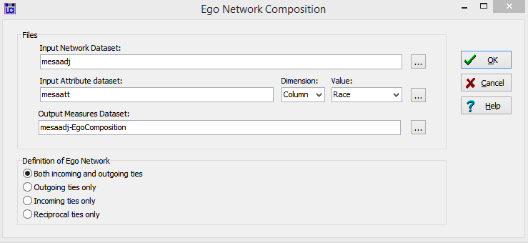
2. Finally, we can use NetDraw, the visualization software from UCINET’s developers to look at the network. To open NetDraw, click the visualization icon in the toolbar:  
   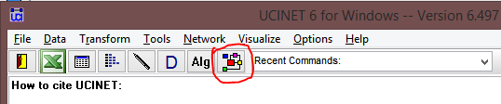  
   Click the file folder with “u” icon to load your ucinet adjacency data into Netdraw. The initial layout already shows the basic structure of the main component, the smaller components, and the isolates:  
   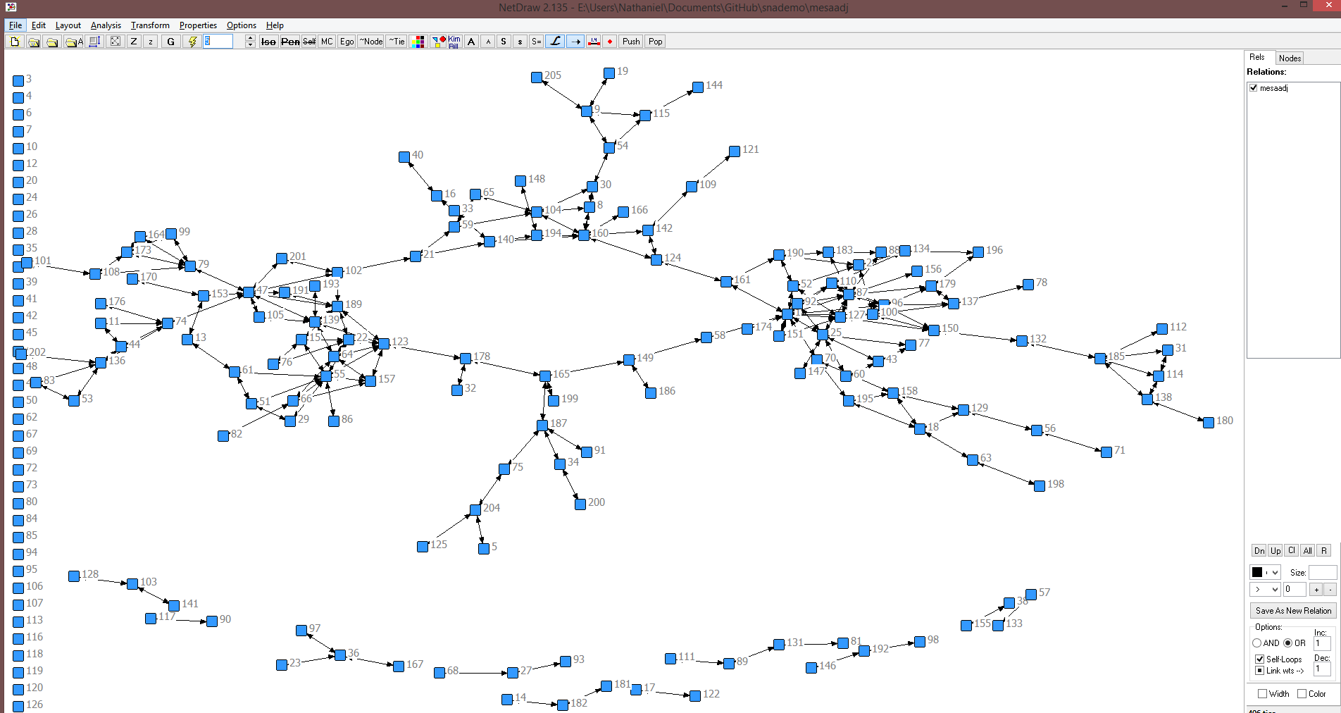
3. NetDraw only knows about the ties right now, but you can read in your attributes by choosing “File- Open- UCINET dataset- Attribute Data”:  
   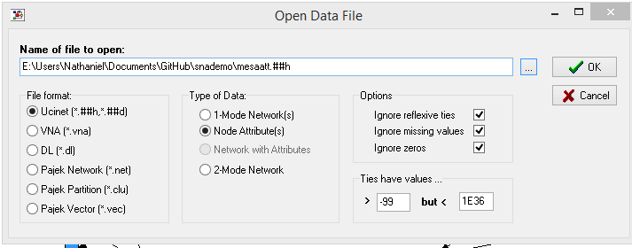  
   NetDraw is also capable of calculating some centrality and clustering measures itself (rather than using the UCINET dataset you created) and using them in your visualization.
4. For now, we will use grade to group and color nodes. Open the “Layout – Group by Attribute - Categorical Attribute” dialog and select Grade, leaving the scrunch factor at default:  
   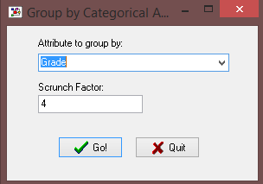  
   You now have a graph with six clusters (one for each grade), but no way to tell which is which.   
   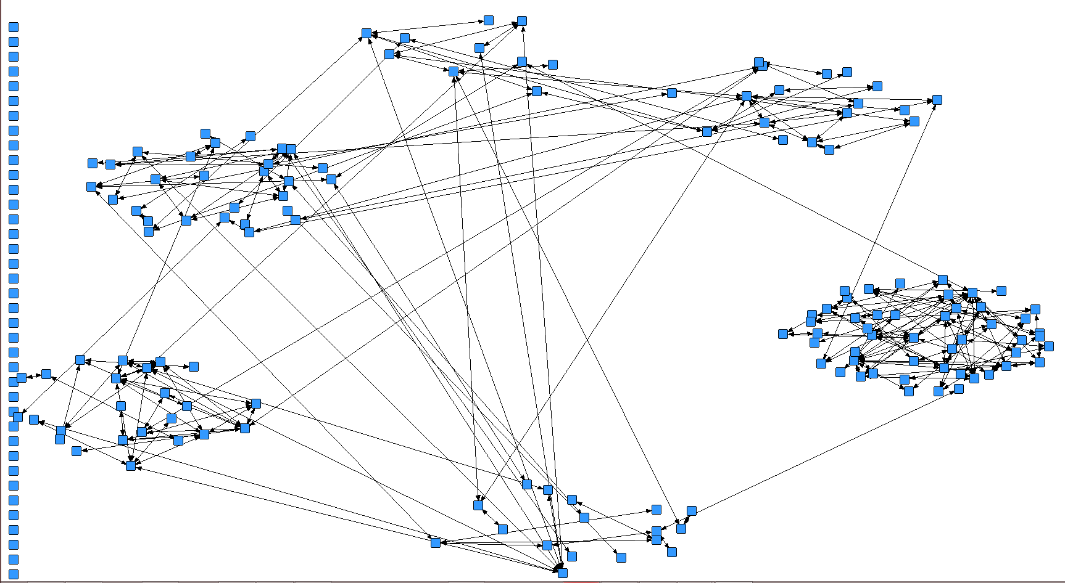  
   To remedy this, click the colors box on the toolbar or open “Properties – Nodes – Symbols – Color – Attribute Based”. Select Grade in the dropdown and click the check to see what happens:  
   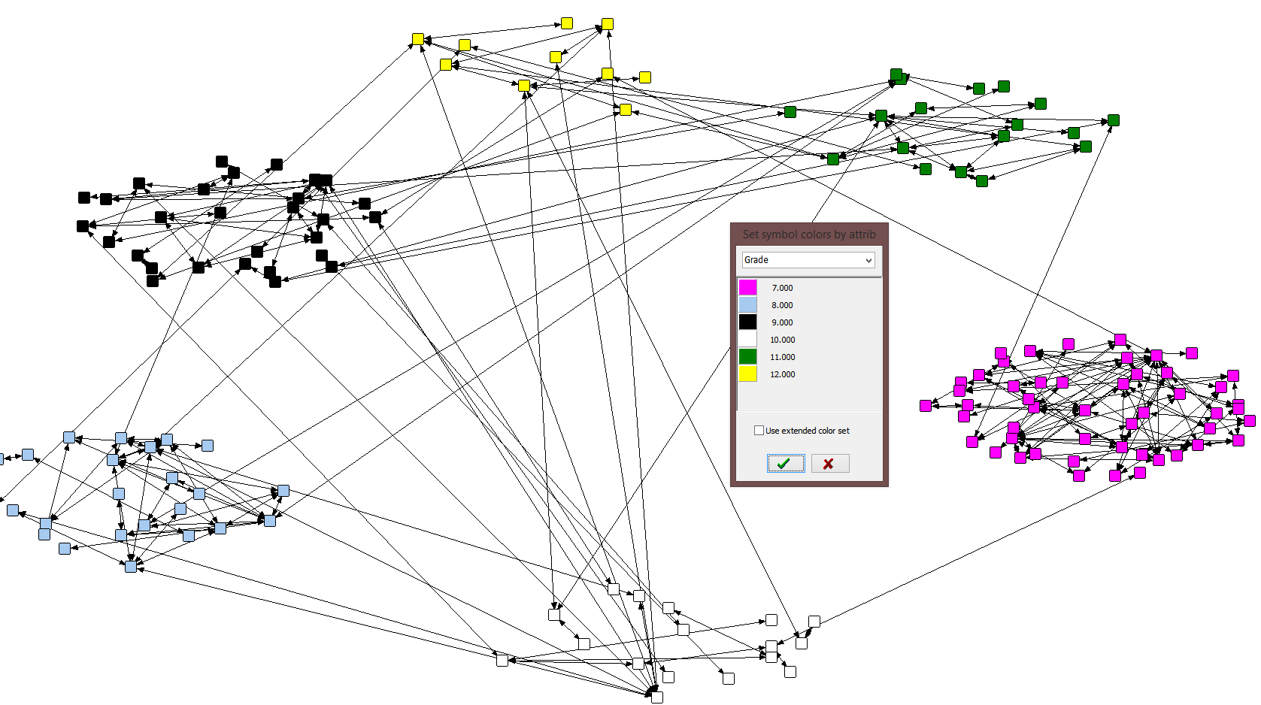  
   A story is starting to emerge. The 7th graders on the right are densely connected to each other but have only a very small number of cross-grade ties, whereas the other classes are more diverse in the grades they associate with.
5. If your gender or race data was coded as numbers, you could also use the shapes button on the toolbar to adjust the shape of nodes based on the attributes. We will however use “Analysis- Centrality Measures” followed by “Properties – Nodes – Symbols – Size – Attribute Based” to set the size of our shapes based on degree (number of friends):  
   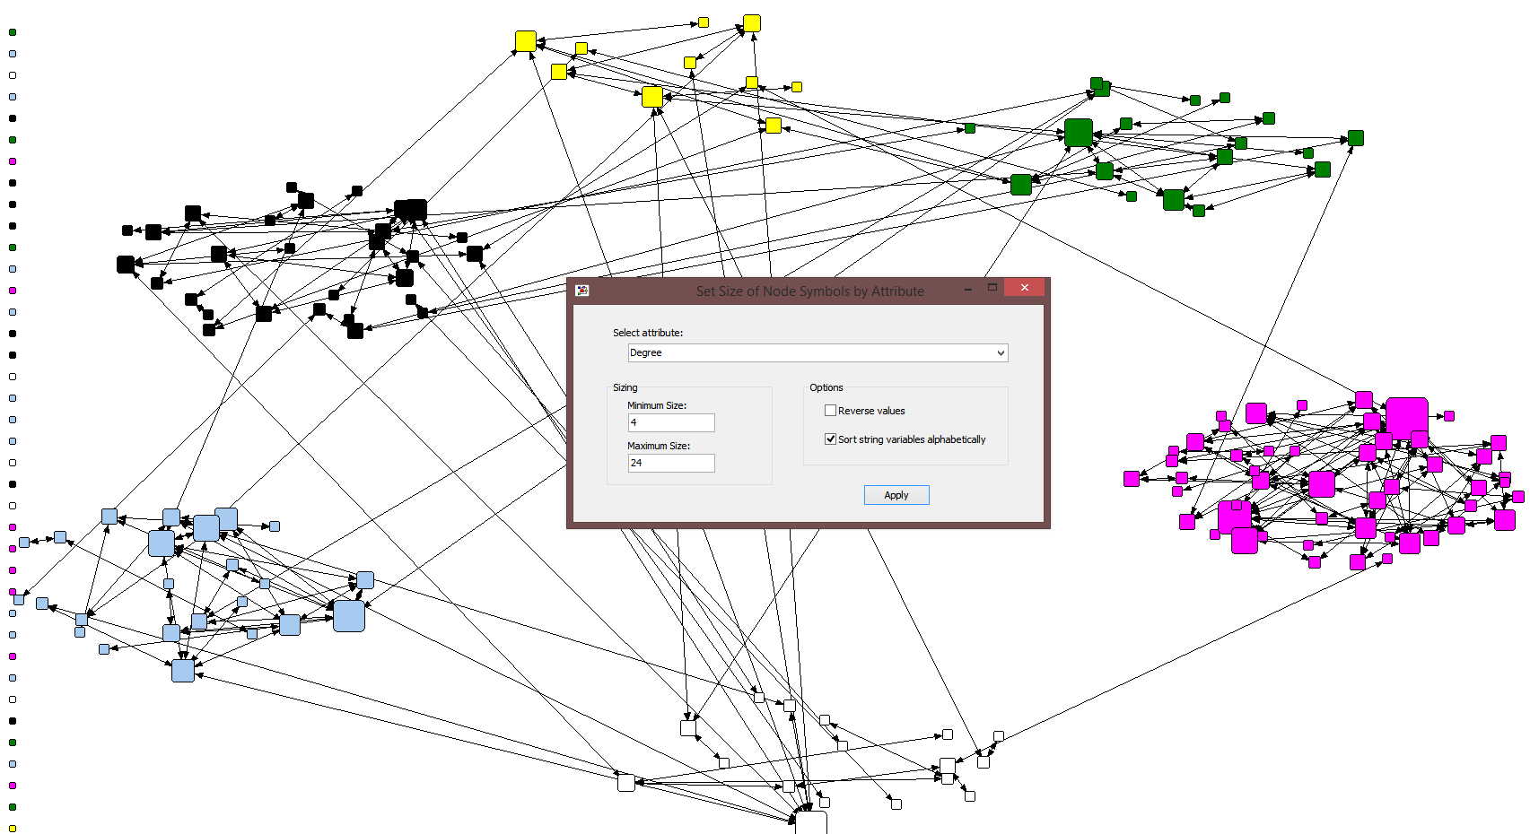
6. Explore the options in NetDraw, being aware that options in the menus or toolbar are not always in the other. Two useful options are removing isolates or keeping only the main component. The visualizations can be saved using “File- Save diagram as” and any attributes or changes you make to the node selection can be saved using “File- Save data as”. Nodes can also be manually dragged to a new location if you prefer.
7. Finally, note that, unlike NodeXL, NetDraw does little to document how you created a visualization. If you are planning on sharing or publishing it, make sure to carefully track the options and steps you used to produce it, including how the nodes were laid out, what any visual properties mean, etc.